**CIIC has supported 10 startups as part of Global Investor Meet Roadshow**

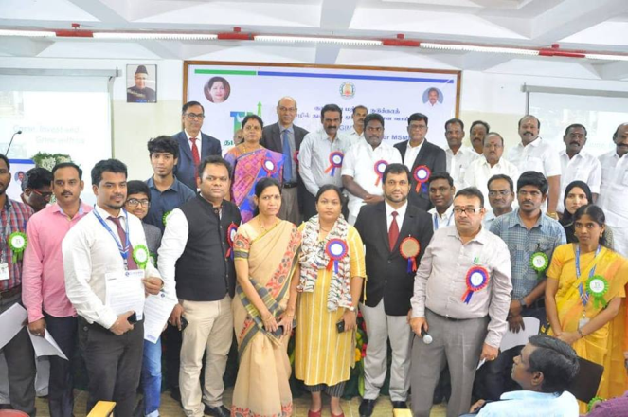

**Venue : B.S. ABdur Rahman University**

**Dept : Crescent Innovation & Incubation Council**

**Date : December 29th,2018**

**Launch of CIIC Incubation Policy and Application for Startups.**

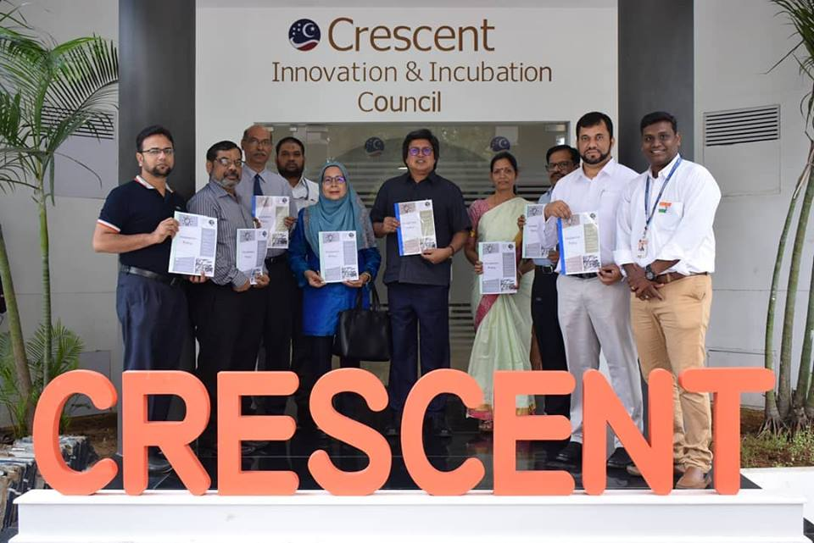

**Our Vice Chancellor Tan Sri Dato Sri Prof.Sahol Hamid Bin Abu Bakar launched the CIIC Incubation Policy and Application for Startups.**

**Venue : B.S. ABdur Rahman University**

**Dept : Crescent Innovation & Incubation Council**

**Date : January 26th,2019**

**Road show on throttling the oil & gas startup Initiative**

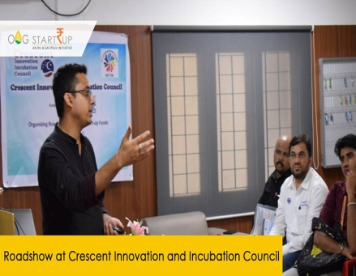

**Venue : B.S. ABdur Rahman University**

**Dept : Crescent Innovation & Incubation Council**

**Date : April 8th,2019**

**Workshop on Digitalizing the Medical world**

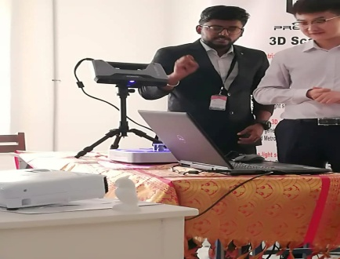

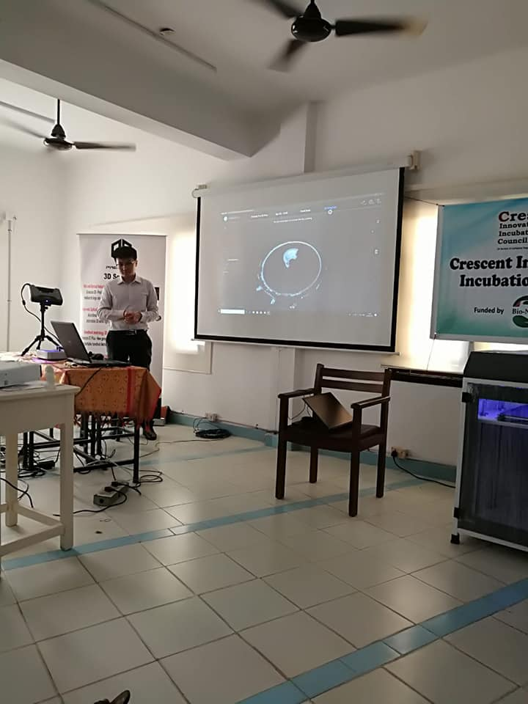

Precise 3D Metrology and Design solutions Pvt .Ltd, Provides comprehensive digital manufacturing solution, which includes 3D scanning ,digital reverse engineering,3D printing and digital inspection for automotive and engineering industries.

**Venue : B.S. ABdur Rahman University**

**Dept : Crescent Innovation & Incubation Council**

**Date : April 24th,2019**

**3D Printing Workshop**

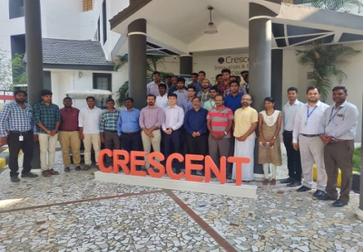

**Venue : B.S. ABdur Rahman University**

**Dept : Crescent Innovation & Incubation Council**

**Date : April 25th,2019**

**Artificial Intelligence Summit**

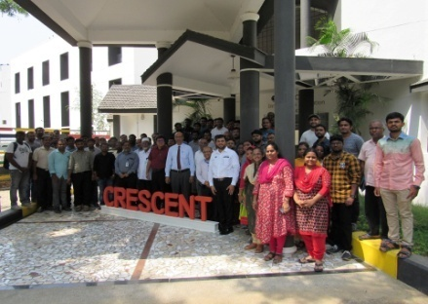

**Venue : B.S. ABdur Rahman University**

**Dept : Crescent Innovation & Incubation Council**

**Date : May 11th,2019**

**City camp on Essentials of Scientific Entrepreneurship**

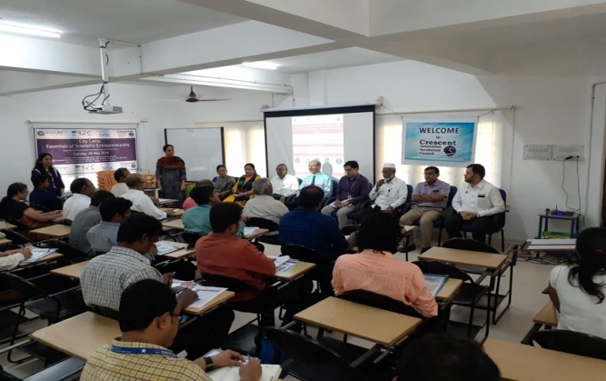 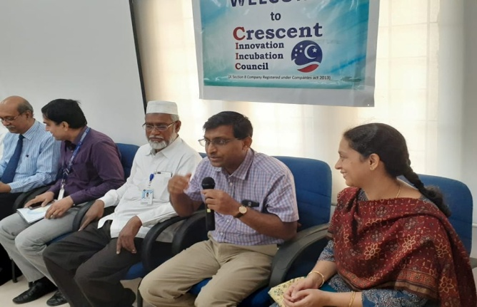

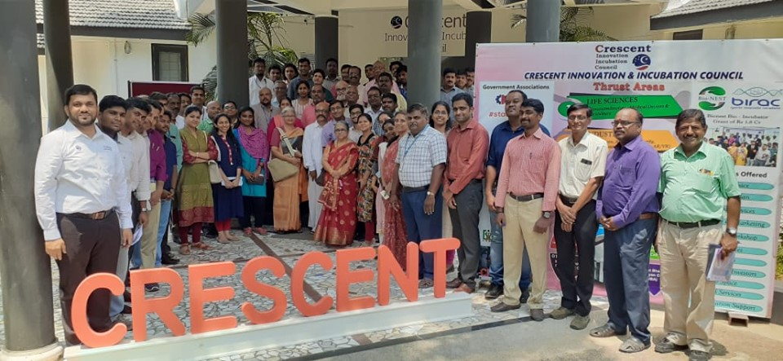

Essentials of Scientific Entrepreneurship, jointly organised by CIIC and Venture Center, Pune. Funded by BIRAC Regional Bio innovation Center. 75+ entrepreneurs, startups across Tamilnadu participated in this program. Thanks to **Dr.Premnath** and Venture Center.

**Venue : B.S. ABdur Rahman University**

**Dept : Crescent Innovation & Incubation Council**

**Date : May 28th,2019**

**C-CAMP**

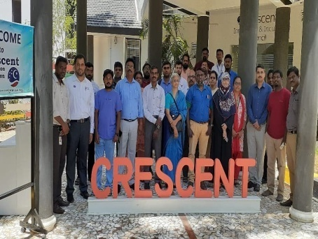

CIIC partnered with CCAMP  to host awareness camp on BIG (Biotech Ignition Grant) scheme of Rs.50 lacs support to startups and faculty  on 12th July Friday at 9.30 am at CIIC Seminar Hall.

**Venue : B.S. ABdur Rahman University**

**Dept : Crescent Innovation & Incubation Council**

**Date : July 12th,2019**

**TIE-Chennai**

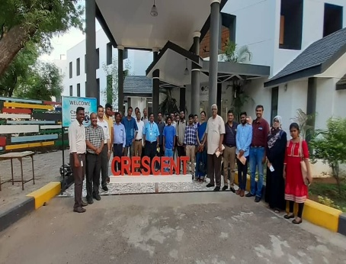

Thanks to TIE Chennai team, CIIC hosted wonderful panel discussion today and many startups were benefited.

**Venue : B.S. ABdur Rahman University**

**Dept : Crescent Innovation & Incubation Council**

**Date : July 12th,2019**

**Herbal Entrepreneurship**

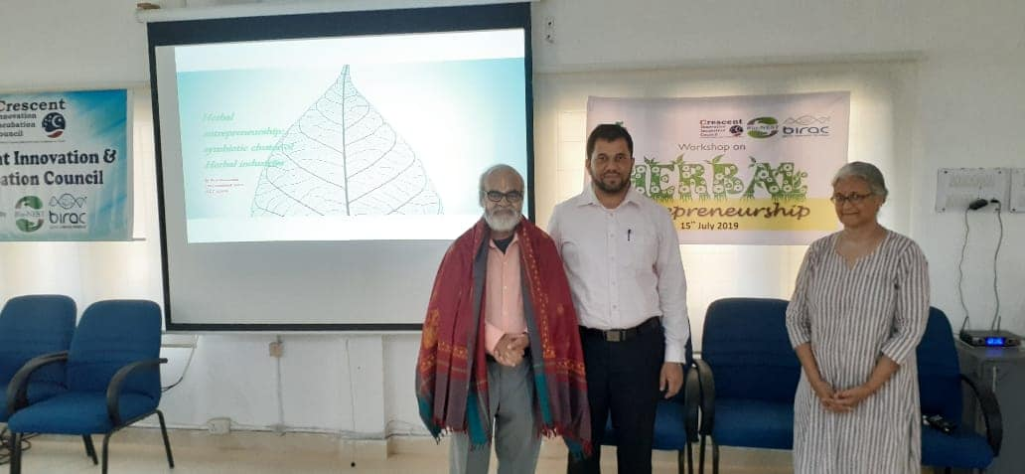 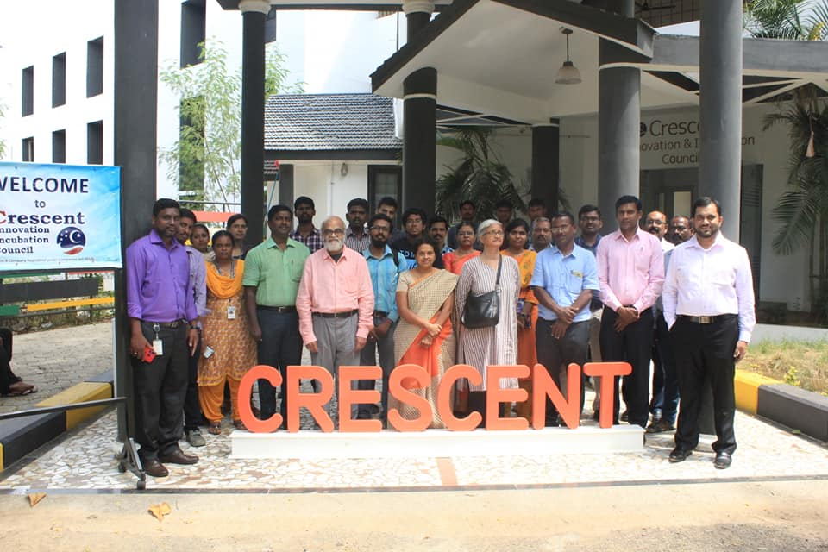

CIIC hosted a "Herbal Entrepreneurship" workshop by Dr.Narasimhan, herbal veteran and founder of Asthagiri Herbal Research Foundation. Many herbal enthusiasts participated and deliberated on the ideas for incubation.

**Venue : B.S. ABdur Rahman University**

**Dept : Crescent Innovation & Incubation Council**

**Date : July 12th,2019**